1. Download Python 3: <https://www.python.org/downloads/>
2. Install Python: right click on the file you just downloaded then select “Run Elevated”

**NOTE: Make sure “Add Python 3.8 to PATH” is checked**

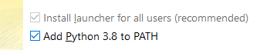

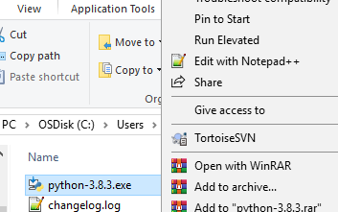

1. Extract the ZIP file

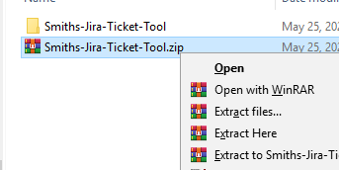

1. Right click on “install.ps1” and select “Run with PowerShell”

**NOTE: if you don’t see “Run with PowerShell”, right click on “install.ps1” -> “Properties” -> change “Opens with:” to Notepad**

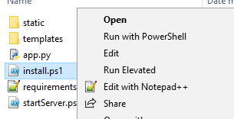

1. Wait until the script finish running

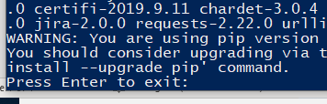

1. Open “app.py” using your favorite text editor

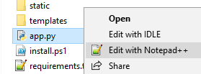

1. Create an API token here: [**https://id.atlassian.com/manage-profile/security/api-tokens**](https://id.atlassian.com/manage-profile/security/api-tokens)
2. Replace line 15 and 16 with your email address and the API key you got from step above



1. Right click on “startServer.ps1” and click on “Run with PowerShell”

**NOTE: The script will take about 10 seconds to run. The website will open automatically.**

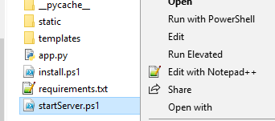

1. If everything is installed and ran correctly, there should be 1 powershell window that look like the picture below.

**NOTE: Do not close this window. The website will not work if you close this window.**

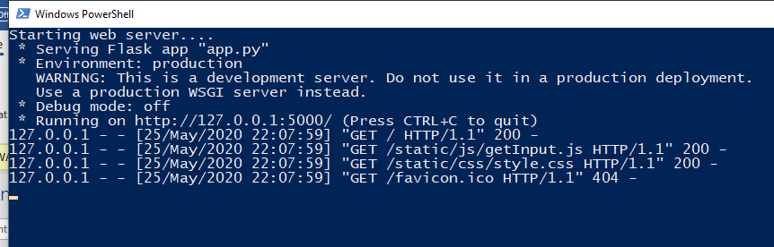

**NOTE: Use project SAN to test the script. Use project SMPUM for official bug tickets.**